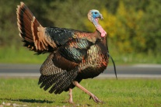

Fall

2019

Info: Randy & Sue 603-253-9518

Cell 603-393-5105

Paul & Diane 603-279-0181

**Please bring a Thanksgiving Type Food Pantry Item to be**

**Donated to a local Food Pantry.**

**Thanks!**

eaa

New Location:

Wicwas Lake

Grange #292

150 Meredith

Center Rd.

Meredith, NH

03253

*Denise Carbonell*

*Calling*

*No Cuer*

*Sat. Nov. 16, 2019*

*7-9:30 PM*

*$8.00 Per Dancer*

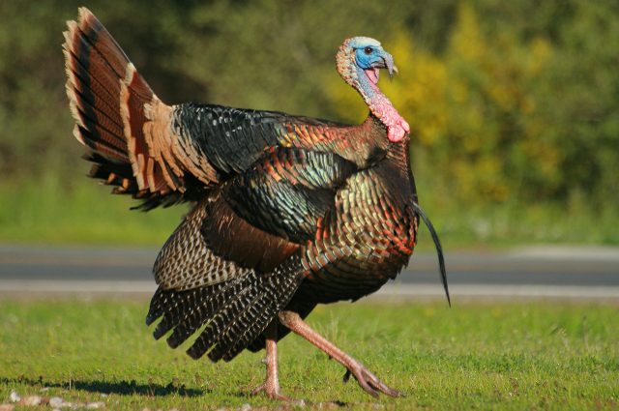

The Winnipesaukee Squares

Invites You to our

“Gobble Fest

Mainstream with Announced Plus Tips”

Sat. Nov. 16, 2019

7-9:30 pm $8l00 per Dancer

New Dance Location:

Wicwas Lake Grange #292

150 Meredith Center Rd.

Meredith, NH 03253

The Winnipesaukee Squares Invite

You to our Gobble Fest